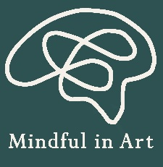
Mindful in Art
Referral Form

Name
DOB
Gender
Year group
Date of referral
Young Persons Details

Name
Role
Email
Telephone
Referrer Details

Is the young person on the SEND register?
Yes No

Please provide relevant information:

Does the young person have an EHCP
Yes No In the process
Please provide any relevant information:

Current educational status
On roll Reduced timetable Awaiting placement
Please provide relevant information:
Please provide as much detail as possible to help us understand the young person’s needs.

What kinds of support or interventions has this young person been involved in previously, and which of those have they responded to best?

What would you like this support to focus on? (For example: emotional wellbeing, regulation, confidence, positive interactions.)

Are there any safeguarding concerns or involvement from external agencies that we should be aware of to help keep the pupil safe and supported?

Are there any behaviours or stress responses we should know about, and what strategies have been effective in helping them feel calm, safe, and regulated?

Is there anything else you feel would be helpful for us to know in order to support this pupil effectively?

Please add a password and send your completed form to info@mindfulinart.com along with the password on a separate email.

Kind regards
Mindful in Art

